

EVS & ESC GUIDE FOR VOLUNTEERS

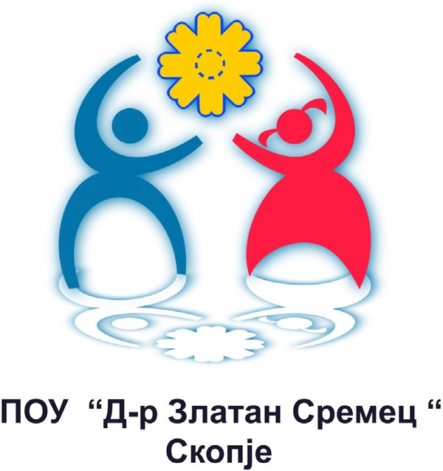

## WELCOME TEAM

Dear volunteers,

Welcome to your ESC, welcome to Macedonia! In this Information Guide you will find some basic information about Macedonia, Macedonian capital Skopje, your project and activities you can get involved in.

## ABOUT US

VOLUNTEERS CENTRE SKOPJE is an

organization which will provide support for your ESC project. We are a non- governmental youth organization created in 2006 by former EVC volunteers. The main goal of the organization is to give non- formal educational possibilities to young people, in different fields, on local and international level; to promote the idea of volunteerism and to connect young people regardless of their nationality, religion, political, economical or social status.

Primary school «Dr Zlatan Sremec» is a public special elementary school for education of children with special needs. The school operates according to special programs for work with pupils with intellectual disability, autism and combined disability. The Special Elementary School “D-r Zlatan Sremec”-Skopje for children with intellectual disabilities was opened on 28.08.1972 by the great Macedonian humanist Dr. Ljupcho Ajdinski. The school is one of the four schools for students with intellectual disabilities. The school has 47 employees, most of which are teachers of special education, physical education teacher, music teacher and teacher in technical education. The school has an expert team composed of a speech therapist, a social worker, a psychologist and a special educator.

#### More information about our organization:

[www.zlatansremec.edu.mk](http://www.zlatansremec.edu.mk/)

**MARIJA DELETIKJ**

*Director*

She has an experience in

the NGO sector with youth and with pupils with intellectual disability, autism and combined disability. She is working as special educator and rehabilitator for 13 years. Also, she has an experience as assistant practitioner for developing adapted curriculum for special schools in the Bureau for Development of Education of Republic of Macedonia.

Phone : +389 227 704 46

[e-mail: zlatansremec@yahoo.com](mailto:zlatansremec@yahoo.com)

### MERI NOLCEVA

*ESC coordinator*

She has a master degree in special education and rehabilitation. She will be responsible for all the communications with the volunteers, giving them an orientation training. She has been working in the NGO sector with youth from different social background so that will be an advantage for the new volunteers because they will communicate with experienced personnel.

[e-mail: mnolceva@gmail.com](mailto:mnolceva@gmail.com)

### ANDREJ NAUMOVSKI

*Project coordinator*

He has a master degree in Intellectual Property Law. He is interested in local development, enviroment, as well as in non-formal education and youth participation in society. He attended Summer Law Institute in China and he took part in several youth exchanges, as a team leader and facilitator. He is experienced in writitng Erasmus+ projects. He did also short ESC in Lithuania where he worked with people with atypical development

[e-mail: andrej@vcs.org.mk](mailto:andrej@vcs.org.mk)

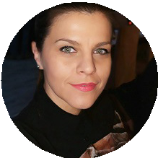

»POU » D-r Zlatan Sremec

## WHAT IS EVS & ESC?

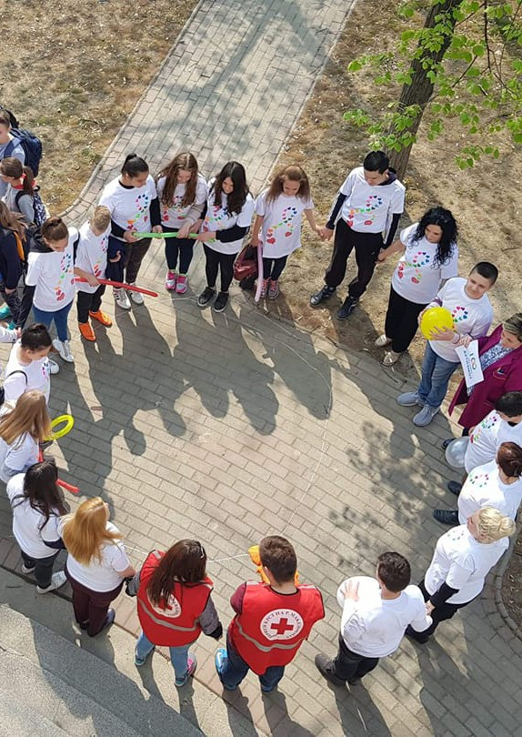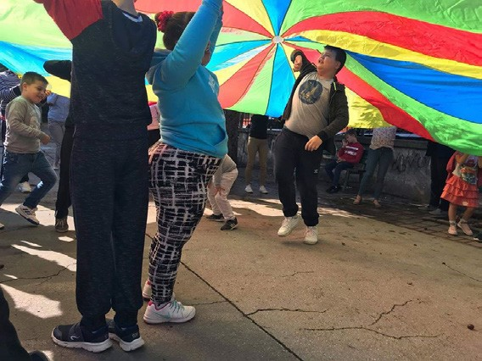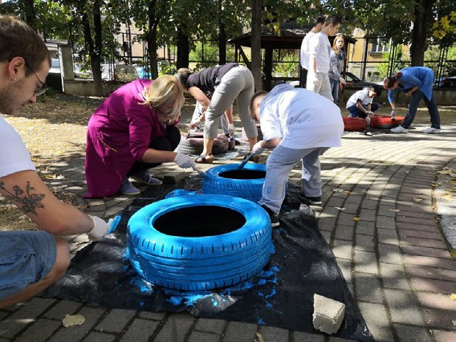

European Solidarity Corps (former European Voluntary Service, ESC) is a partnership between two or more NGO´s. The ESC is funded by European commission and aims to improve young people skills. Volunteers participate in ESC through the supporting organization in the country where they live and the receiving organization that receives and hosts them during their period of project. The European Solidarity Corps is the new European Union initiative which creates opportunities for young people to volunteer or work in projects in their own country or abroad that benefit communities and people around Europe.

You will receive free accommodation, food, insurance and pocket money and language courses. You can work in a wide range of fields such as culture, youth, sports, children, cultural heritage, arts, environment, and development cooperation. In the end of your project you will receive a certificate confirming your participation – The YOUTHPASS. Projects are for people between 18 - 30 years old. Projects supported by the European Solidarity Corps (ESC) can last from two to twelve months. They will usually be located within the European Union Member States, and you can make it only once in a lifetime .

## ACTIVITIES

CULTURE, CREATIVITY, YOUTH and CHILDREN WITH DISABILITIES are the

key words of your ESC project. During your volunteering, you will have the oppurtunity to get involved in various activities depending on your profile and on the period of your stay in Macedonia.

For your main project, you will be involved in on-going local activities, meaning help and support with the social group in the Special Primary School. For instance, as a volunteer, you’ll be encouraged to come up with own ideas leading to the improvement of the on-going activities of the school.

Moreover, you’ll have the opportunity to get engaged in school’s other activities: these activities can involve taking part in events organized in cooperation with other organizations e.g. fundraising events, public raising awareness events, events aiming to promote volunteer work, information days, help and support in the process of developing new projects and initiatives.

Also workshops and trainings will be part of your project, to let you the chance to develop new competencies.

And then, especially in the second part of your project, you’ll be able to work on personal project and activities, to work on the development of personal ideas.

In a bit more global concept, SPS «Dr Zlatan Sremec» cooperates with other organizations and institutions. One of the key aims of this cooperation is to raise awareness of the lives of children with minor disabilities in their psychological and physical development, multiple disabilities and autism and break the stereotypes and prejudices that people might have.

## PARTICIPANT PROFILE

* Should be 18+
* Beeing strongly interested in the activities
* A previous working experience with youth with disabilities could be a plus for you
* Highly motivated, flexible and willing to face the different challenges that each day

brings

* Good communication skills in English
* Interested to work with pupils and young people,
* Should be open to live and work in a new environment
* Needs to have high sense of responsibility

- Open to cooperation, ready for teamwork

## ACCOMMODATION

You will be hosted in one of our flats. Both of them are in «Kisela Voda», really close to the office with a view to the mountain Vodno! In the first one there are 5 rooms, 1 bathroom, 1 kitchen with living room and 1 balcony. In other one, there are 5 rooms, 1 living room, 2 bathroom’s and 1 balcony. It’s close to markets «Vero and Stokomak» and lots of commodity. Flats are located at 15 min from city center by walk. Train and bus station is also near, around 15 min walk. Each volunteer have a room. You will be sharing kitchen and other facilities with other ESC volunteers. In the flat you can find all necessary stuff as kitchen stuff, blankets, bed clothes, towels, etc. The Wi-Fi internet is available in flats as well. It’s recommended for you to bring your towels.

Address of the first flat: Ivan Kozarov 24/2-4 Kisela voda, 1000, Skopje

Address of the second flat: Emil Zola 3-2/3

Kisela Voda , 1000, Skopje

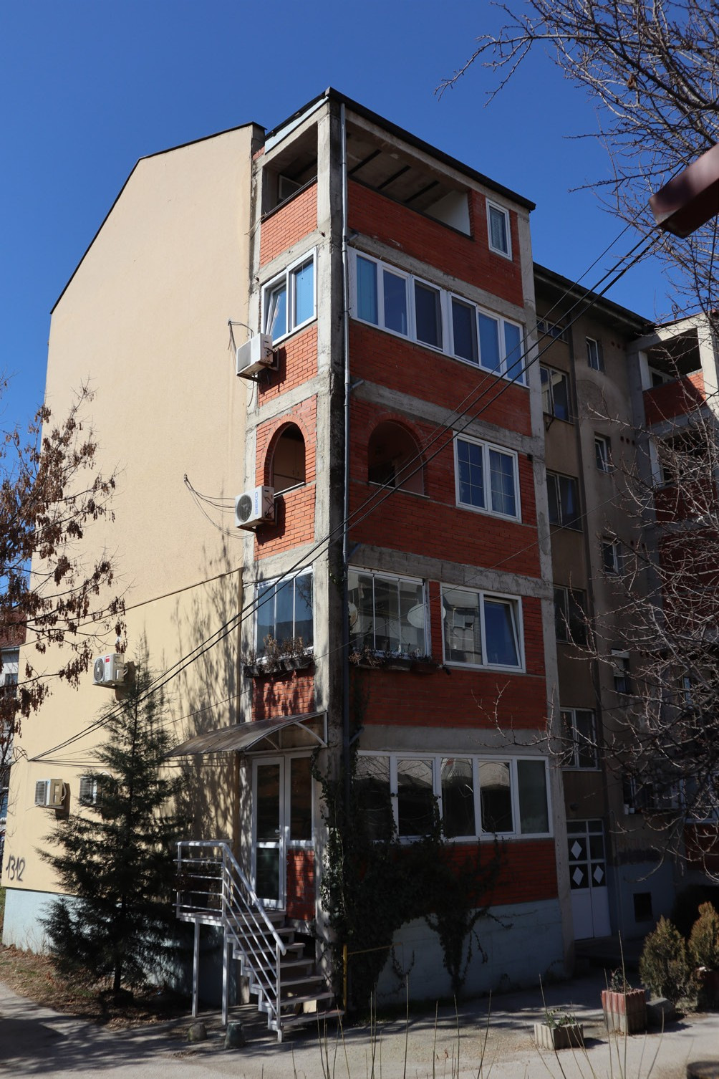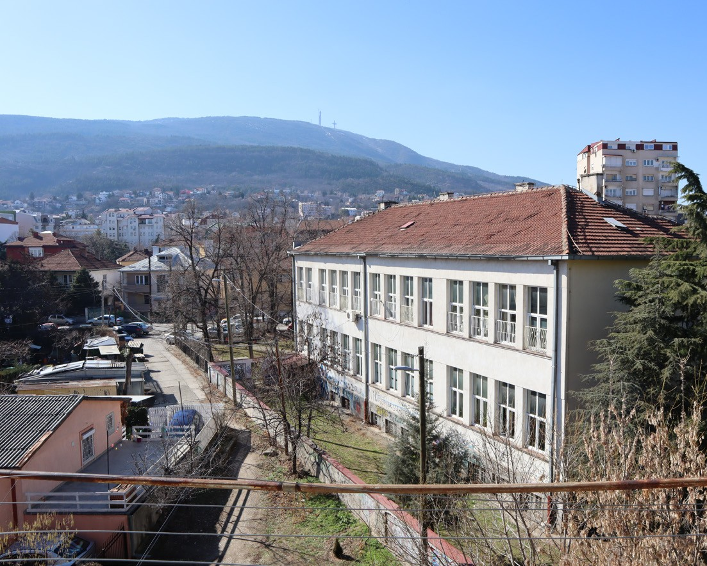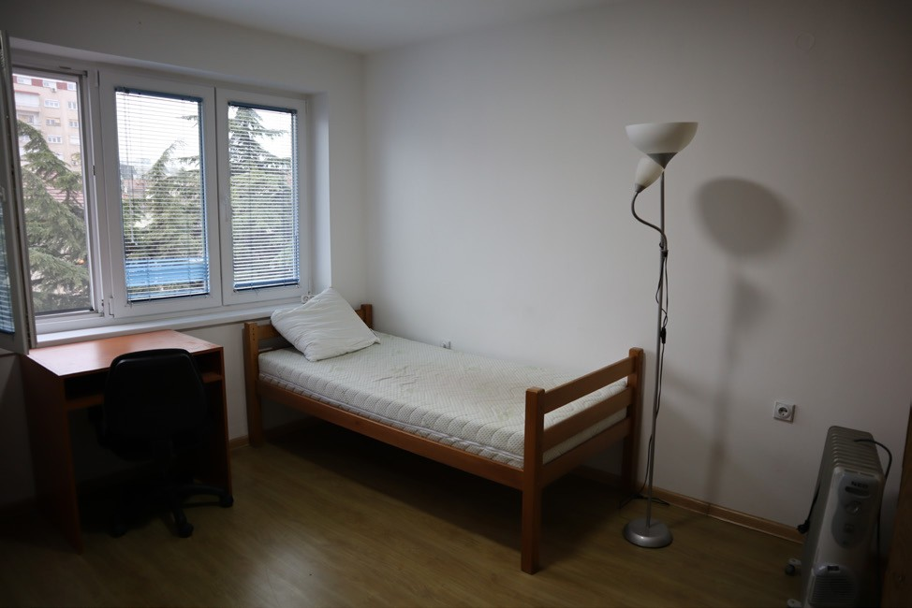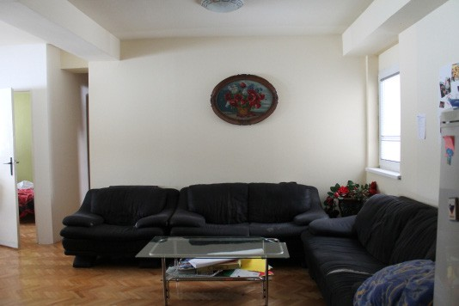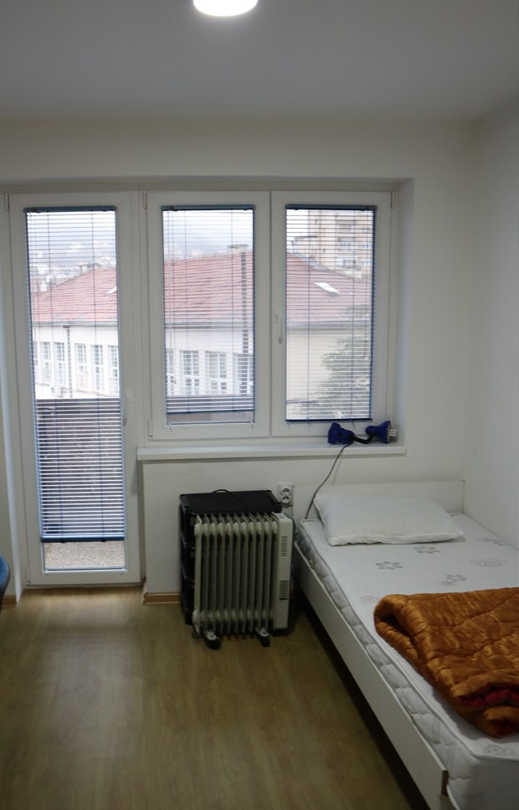

## MENTOR

Your mentor will be around you during all your ESC, you can think that your mentor willl be your first friend. The mentor will help to arrange practical things and stay in Skopje. During the first days s/he will takes you around the city, shows the most important and interesting places. During the whole project the mentor will help you with practical arrangements and other issues. S/he will be a person who will try to make your ESC the best experience! Mentors in our organization are mostly university students and/or young people who were by themselves ESC volunteers or willing also to become ESC too.

## MONEY

In Macedonia we use Macedonian denars (MKD). The

current exchange rate: 1 EUR = 61.5 MKD. You can exchange euros and denars without any problems here. Most of the biggest shops and restaurants accept also credit cards, but take care about fees of your bank. Just when you will leave Macedonia, do not forget to exchange your money back, because you cannot exchange MKD outside Macedonia! In Macedonia ESC volunteers receive 90 € / 5500 MKD pocket money, as well as 100 € / 6100 MKD food allowance.

## LANGUAGE

Lets speak Macedonian! During your ESC time you

will take part in classes of Macedonian language so you can feel free and more comfortable in daily life situations.

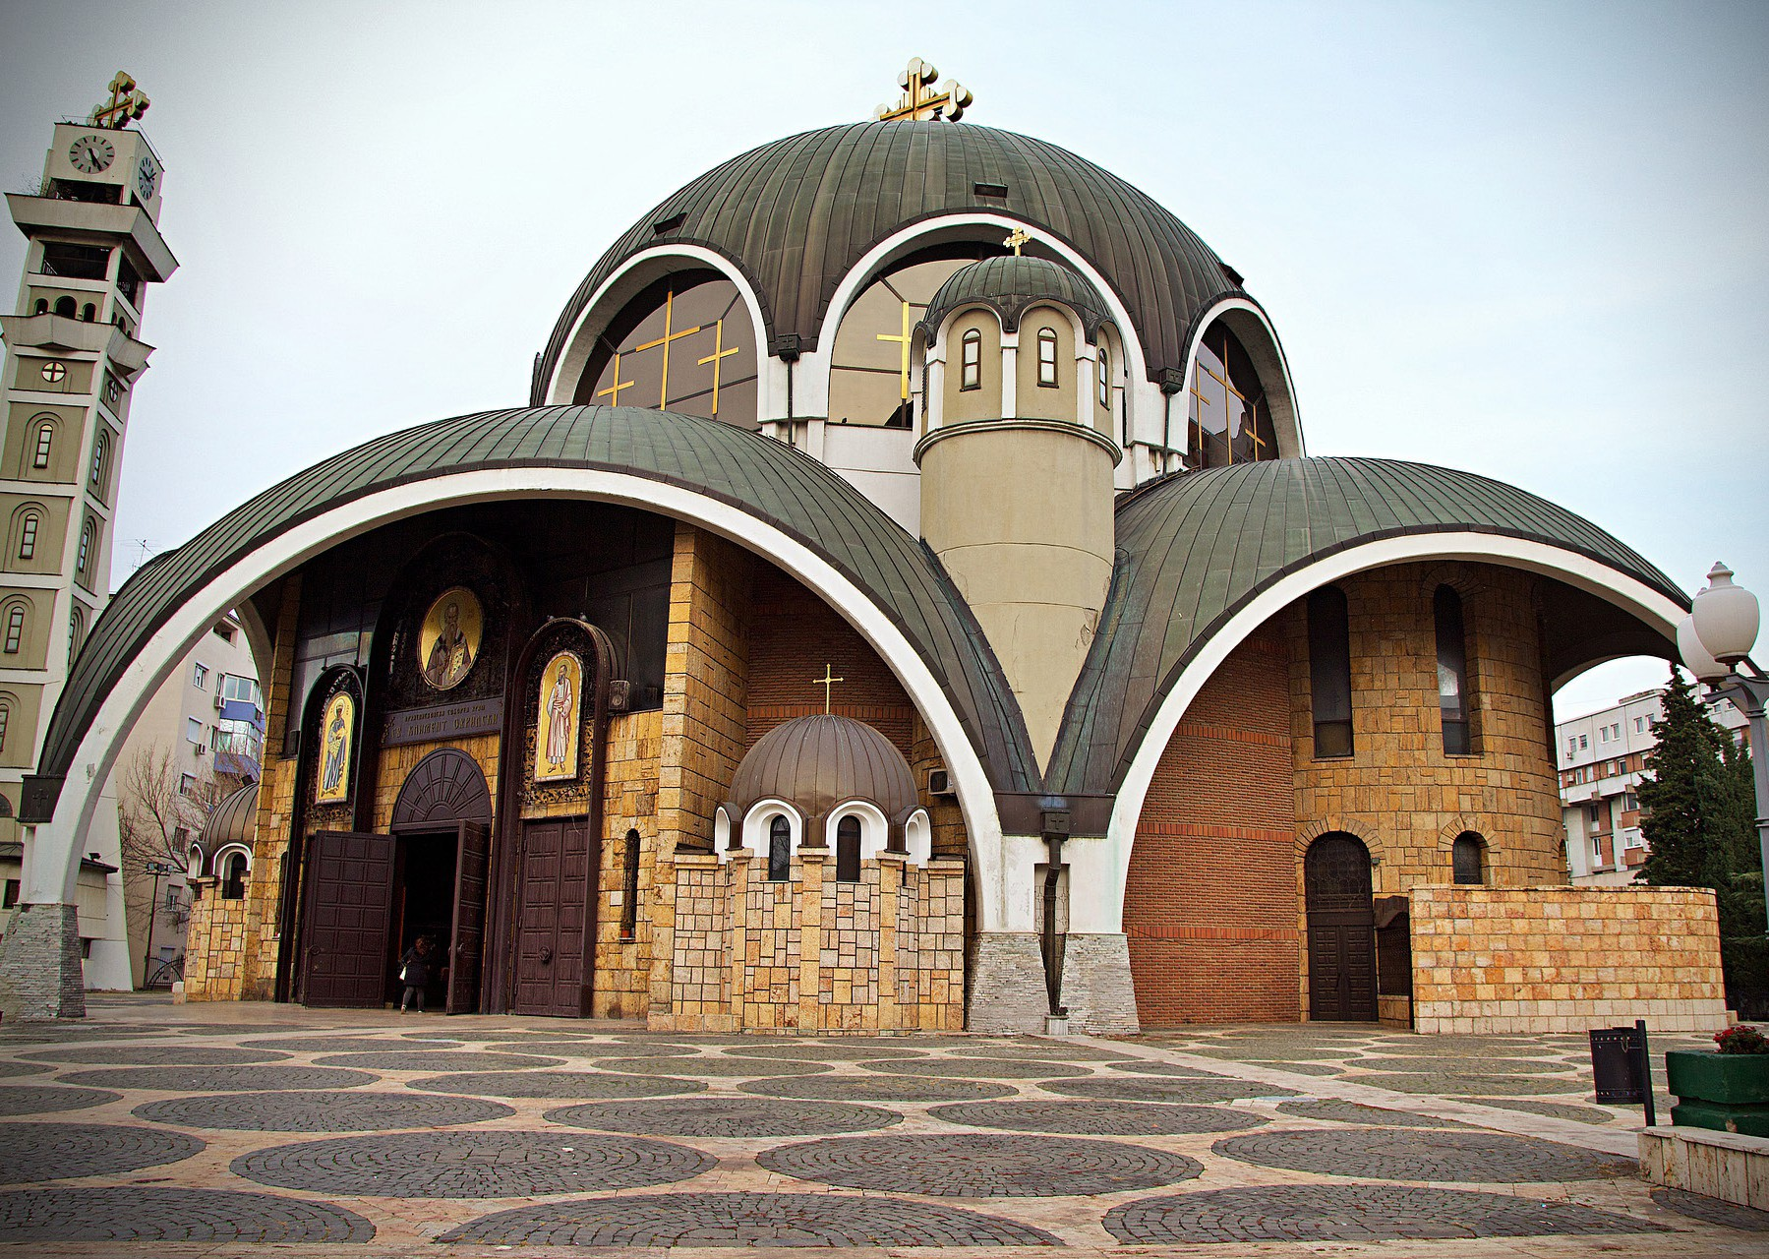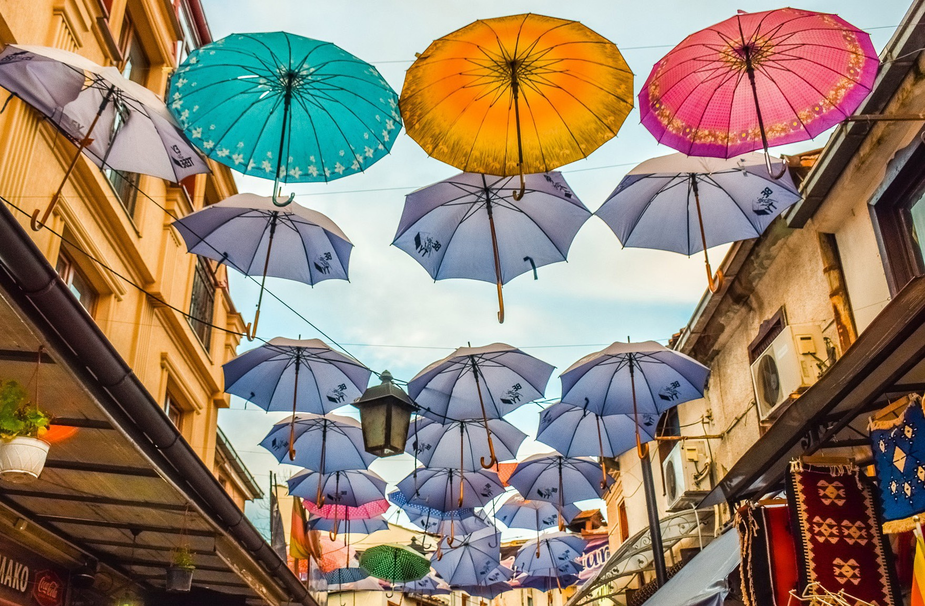

### Church of

**St Clement of Ohrid**

**The Old Bazar**

WEATHER

In summer it is hot, really hot in Macedonia. Especially in June and July you can expect temperatures over 40 °C. And winter can be cold with a lot of snow.

## INSURANCE

During your ESC you are insured by Cigna that covers all the expenses for visits to doctors, operations etc. Your sending organization should arrange your insurance, please ask about it, if you did not receive any information until now. If you have some specific health problem, please, take your medicine with you, be informed what should be done in case your health condition gets worse, also be sure to leave correct emergency contact information to us and to your sending organization.

### View from the Skopje Fortress

TRANSPORT

In the case if you want to take a taxi: taxi in Skopje is cheap, just remember that taxi drivers sometimes do not know where the place where you want to go is. For one ride in the city you should pay from 100 MKD to 200 MKD. Two of most reliable companies:

Global Taxi - call to 070 515 180

Nashe Taxi - call to 02 15 152

In Skopje there is also local bus that you can use with a bus card, one trip is 35 MKD and with it its easy to get places more far away. There’s also regural transport to cities and countries near by. Transport will be provided to volunteer in necessary situations like events outside of Skopje or workshops from bus ride away.

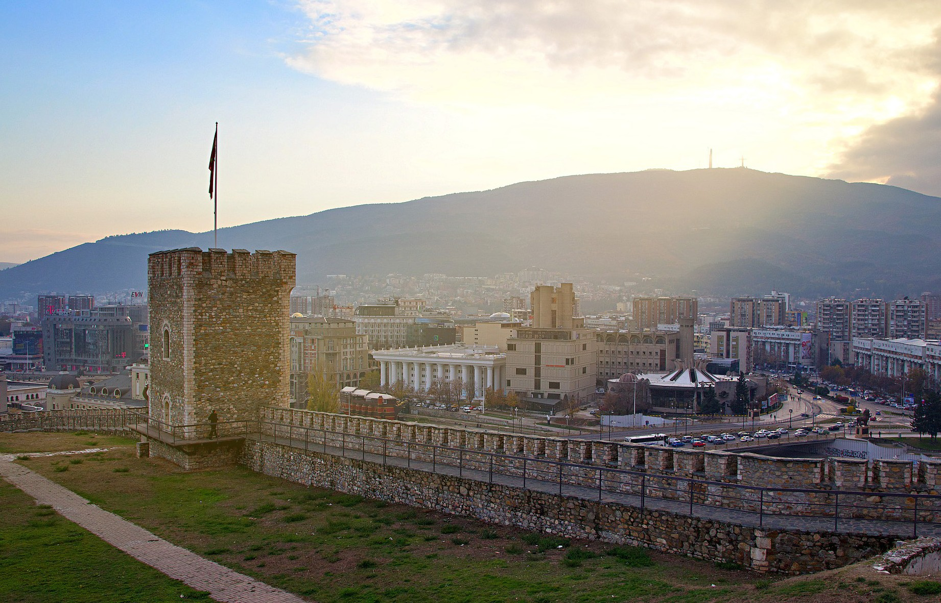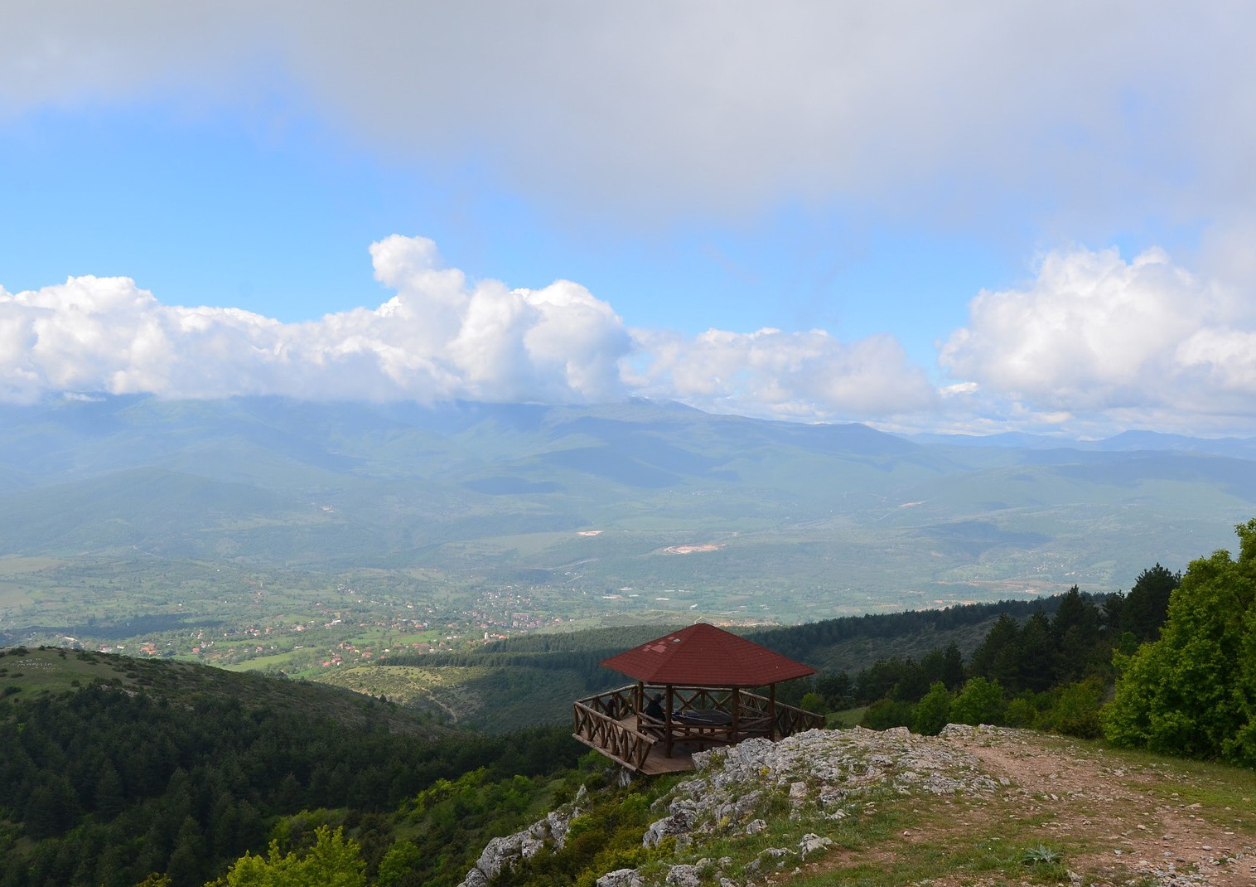

### View from the back of Vodno



TRAININGS

Your on-arrival training will take place in Skopje at the beginning of your ESC project, or sometimes few months after your coming. This training will be organized by the National Agency, the institution in charge of accreditation of ESC organizations and organizing trainings for volunteers in Macedonia. Then the National Agency will also organize your midterm training that will also take place in Skopje. These two trainings will be the occasion for you to meet and making relationship with other volunteers coming from the other organizations and from local associations.

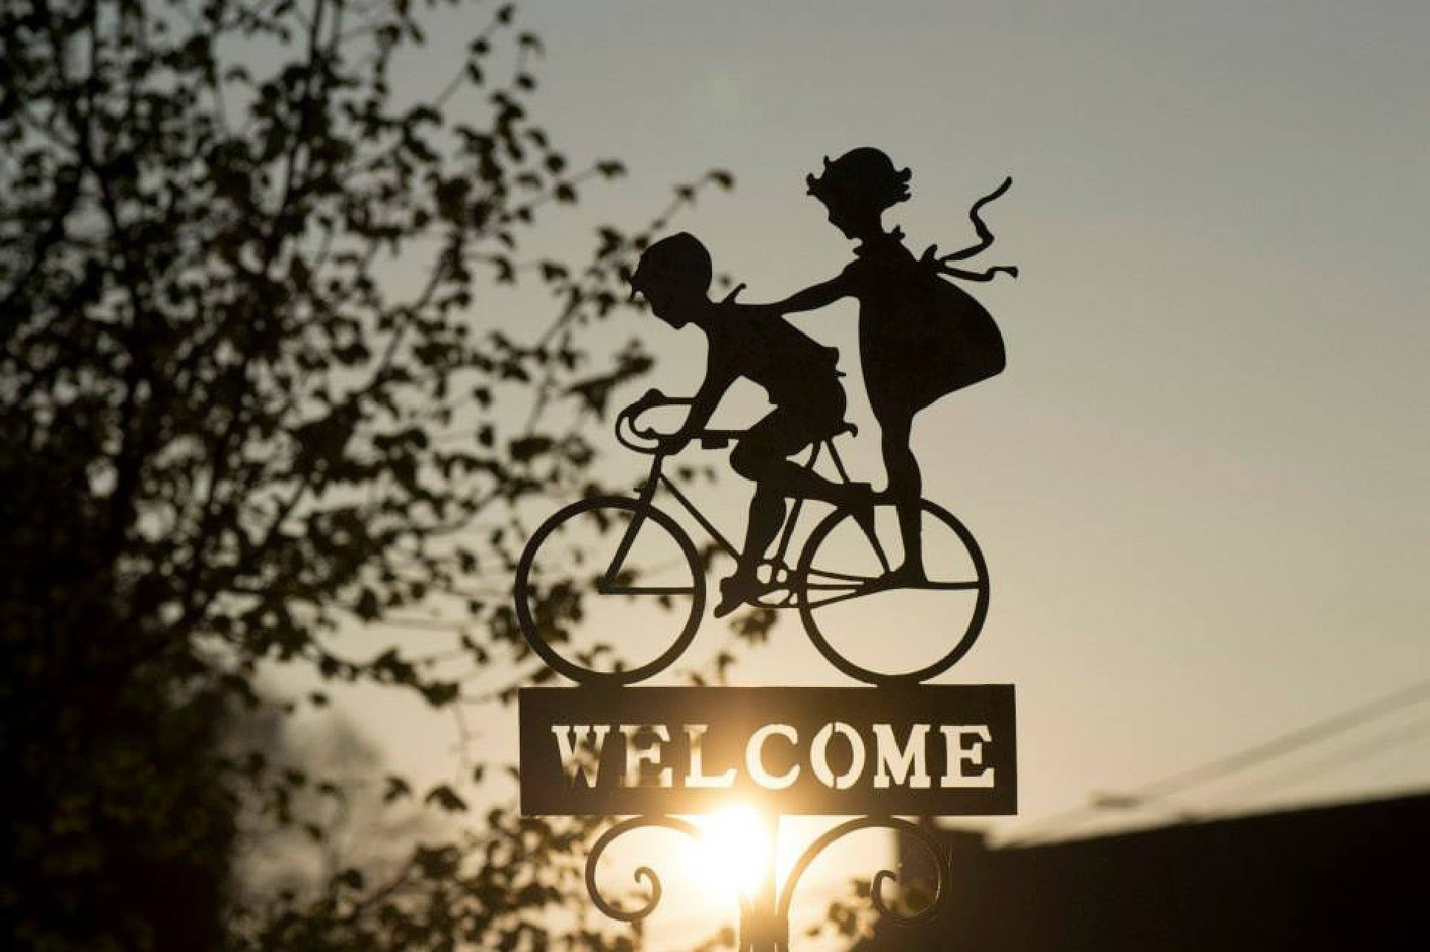

CHECK LIST

*Check if your travel documents (you can enter Macedonia with ID card or passport) are VALID at least three

months after your project to be finished.

*Pack with you all the medicaments that you’ll use.

*You will receive Macedonian sim card for easier communication with hosting organization, mentor, local

friends etc. so you can discharge the deal with your operator from your own country.

*As there is WI-FI internet available in our office, house and other public places in Skopje feel free to take with

you your laptop or tablet.

*Get ready for project activities: brainstorm ideas for intercultural nights as for your workshops and share your

ideas with us.

**Useful phone numbers :**

Police: 192

Emergency: 194

Firemen: 193

Information Center: 188

LINKS

[http://skopje.fr](http://skopje.fr/) <http://www.exploringmacedonia.com/> <http://www.skopjeonline.com.mk/>

Skopje bus station <http://sas.com.mk/index.php> [http://www.jsp.com.mk](http://www.jsp.com.mk/)

<http://www.balkanviator.com/en/>(not just for Macedonia)

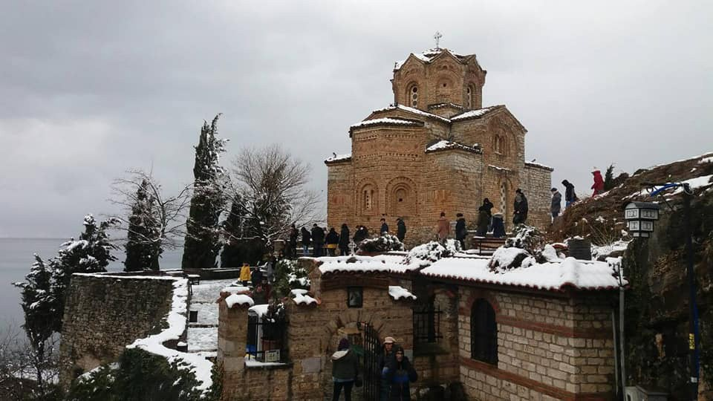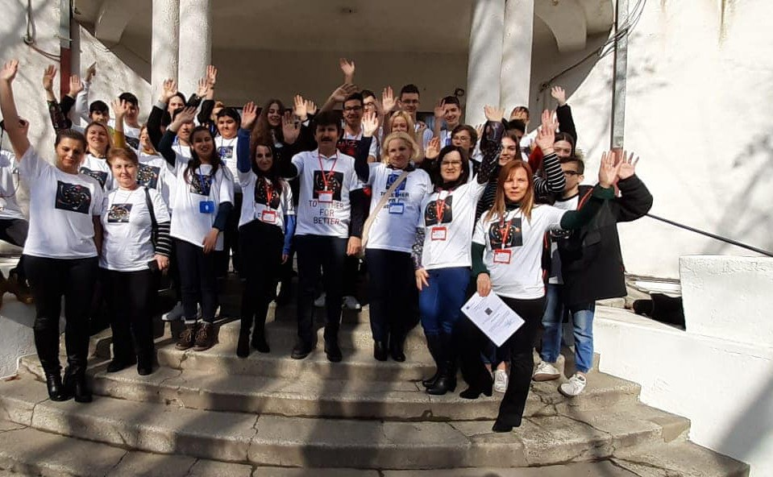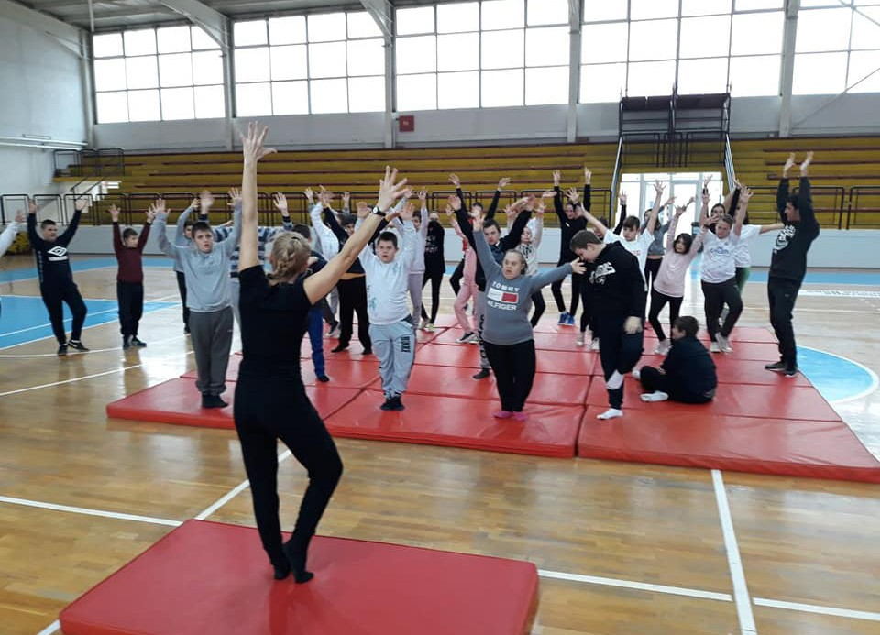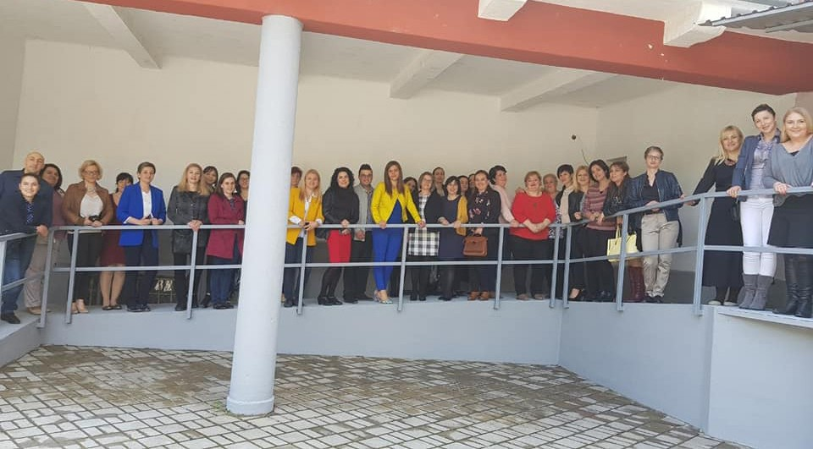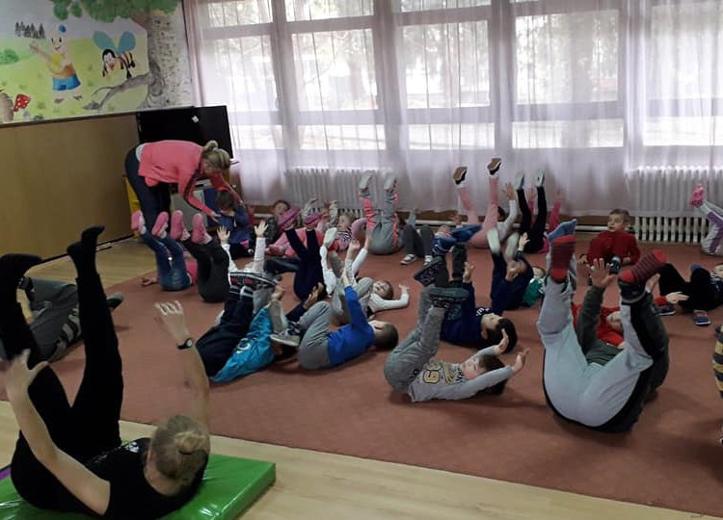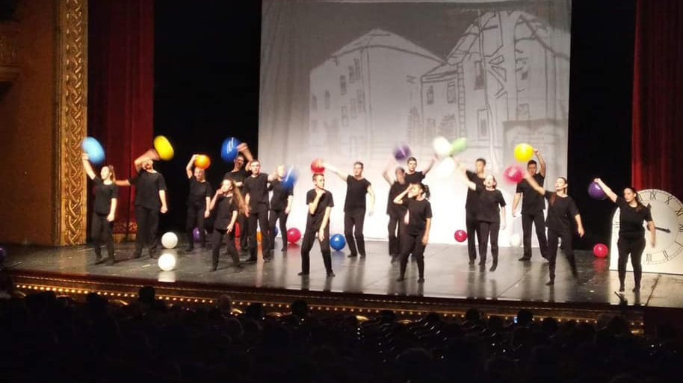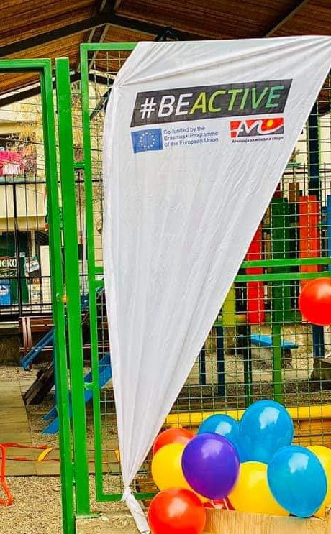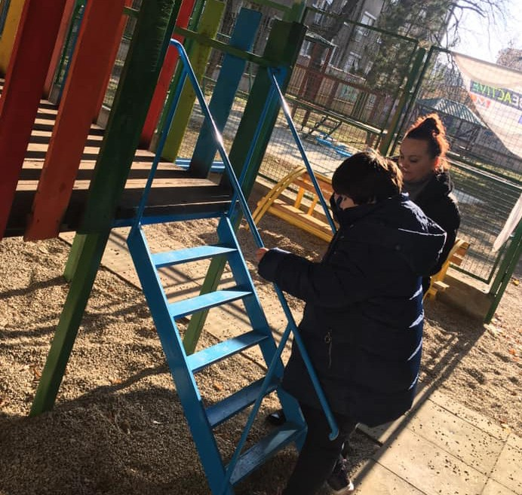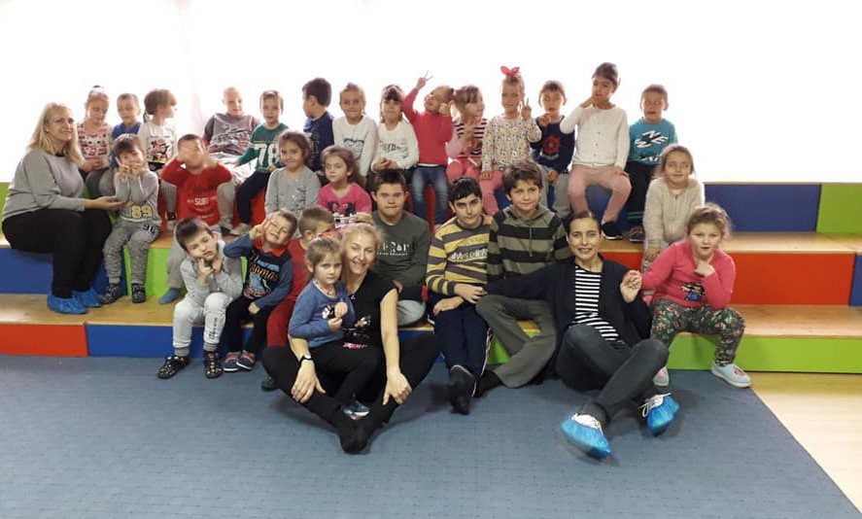

# Useful Sentences

Good morning: Dobar den - Добар ден Hi: Zdravo - Здраво

Thank you: Fala - Фала Goodbye: Prijatno - Пријатно

How are you?: Kako si? - Како си? Bye!: Chao! - Чао!

See you later!: Se gledame! - Се гледаме!

What´s your name?: Kako se vikash? - Како се викаш? My name is...: Jas se vikam... - Јас се викам...

Please: Тe molam - Те молам Okay/Good: Dobro - Добро How much?: Kolku e? - Колку е? What?: Shto? - Што?

Why? Zoshto? - Зошто?

Water: Voda - Вода Wine : Vino - Вино Beer : Pivo - Пиво

Cheers!: Na zdravje! - На здравје! C’moon/Here we go: Ajde - Ајде

Why not?: Zosto da ne? - Зошто да не ?

I know: Znam - Знам I don´t know: Ne znam - Не знам

I don´t understand: Ne razbiram - Не разбирам No problem: Nema problem - Нема проблем There is no rakija!: Nema rakija - Нема ракија

Oh lalala!: Leleee! - Лелеее! Happy: Srekjen - Среќен Beautiful: Ubava - Убава

Oh my god: O boje - О боже!

## Cyrillic Alphabet

|  |  |  |  |
| --- | --- | --- | --- |
| А - a | З - z | Н - n | У - u |
| Б - b | S - dz | Њ - nj | Ф - f |
| В - v | И - i | О - o | Х - h |
| Г - g | Ј - j | П - p | Ц - c |
| Д - d | К - k | Р - r | Ч - č |
| Ѓ - gj | Л - l | С - s | Џ - dž |
| Е - e | Љ - lj | Т - t | Ш - š |
| Ж - ž | М - m | Ќ - kj |  |

Cool places in Skopje

USEFUL

**Fitness room Atanasovski** *- Close to the office, good and friendly staff. 1200 MKD for one month*

**Optika Tri** *- Close to the office, cheap prices and nice guy!*

**Pharmacys** *- One in the same building than the other flat and many near by*

FOOD

**Macrobiotic Sandwiches** - *In GTC*

**Gino** - *It’s a little bit expensive but good*

**Staro Bure** - *In Kučkovo, very good restaurant with fresh meat*

**Zelena Sedmica (or 7 fast food)** - *Popular fast food famous for big portions*

**Galerija 7** - *Turkish restaurant in Old Bazaar*

**Gostilnica Latana** - *Very good Kafeana*

**Plaza de Toros** - *Italian restaurant with nice, big and cheap pizzas or pastas*

**London Cafe Trend** - *Every Sunday 50% discount, but not the best service you could expect*

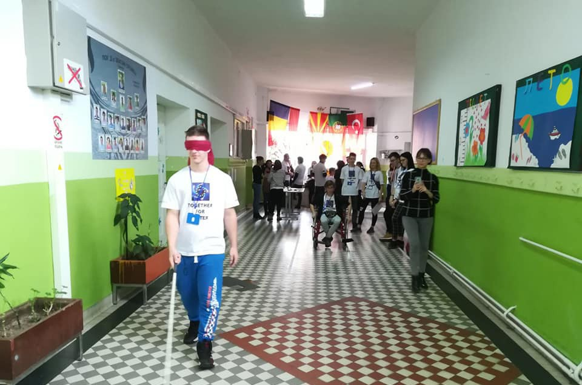

BARS

**Old Bazaar**

Pivnica Rakija Bar La kaña Kapan Ann Allure

**City Center**

**Irish Pub St.Patrick** - *On Vardar’s Key*

**Custom Bar** - *Bikers Bar and sometimes live music* **Cocktail Bar** - *Classic bar and good cocktail around 200 MKD. On Macedonian Street*

**Saloon** *- Different music styles, open every day!*

**Станица 26** *- Nightclub*

**Debar Maalo**

**Van Gogh** – *Every Monday Live music*

**Spalato** - *Good cocktail for 100 MKD*

**Club Marakana** *- Live rock music every weekend*

**Kisela Voda**

**BEERTIJA PUB -** *Pleasant rock bar with concerts*

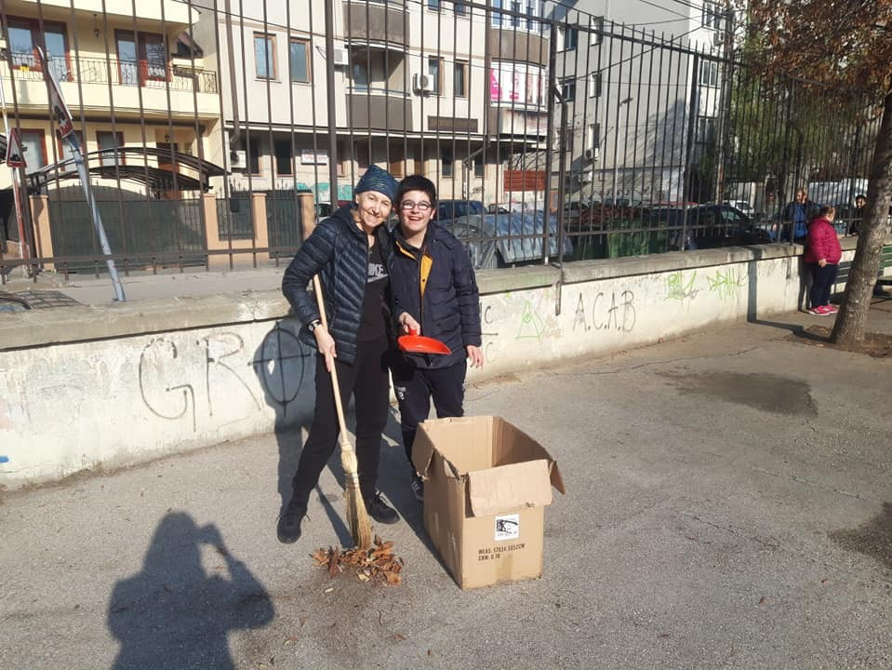

EXPLORE SKOPJE

**Gradski park** *- It’s city park, nice place for walk or to read a book.*

**Gazi Baba park** *- Also nice place for walk or to read a book.*

**Stara Čaršija (or Old Bazaar)** *- Typical place of old Skopje. In this area, you can find Pit Bazar and some cheap restaurants, shops, souvenirs, ...*

**Vodno** - *The most famous mountain in Skopje that you can see from everywhere.*

**Millenium Cross***. You can go by bus and take cablecar to go to the Cross. Also, you can go up by hiking!*

**Matka** - *Beautiful place in nature with canyon and hiking way. You can hike between Vodno and Matka, but you need one day and good preparation! :)*

**Aqua park** *- Classical Aqua park, perfect during hot summer!*

**Bit bazar** *- Bazar for everything! located at the end of Old bazaar.*

**Green Bazar** *Bazar for vegetables and fruits*

**Skopje Zoo** *- On boulevard Illiden - 60 MKD..*

**Macedonian Museum of Archaeology** - *150MKD for students or 300MKD full price.*

**Museum of Contemporary art** - *After the Fortress of Skopje - 50 MKD.*

**Museum of Macedonia** *- In Old Bazaar - 100 MKD*

**National Gallery** *- At the entrance of Old Bazaar in Hammam - 100 MKD - Open Monday to Friday.*

**Museum of the city of Skopje** *- In old rail station, at the end of Macedonian Street - free entrance.*

**Mother Tereza Memorial House** *- On Macedonian Street.*

**Macedonian museum of Uprising** - *After the Stone Bridge - 300MKD - open everyday.*

**Holocaust Memorial** *- After the Stone Bridge - open Monday to Friday - free entrance.*

**GTC (Gradski Trgovski Centar)** *- It’s an old city mall in center of Skopje with a lot of shops!*

**Skopje City Mall** *- The main city mall in Skopje. A little bit expensive and far from the city center, but with international brands.*

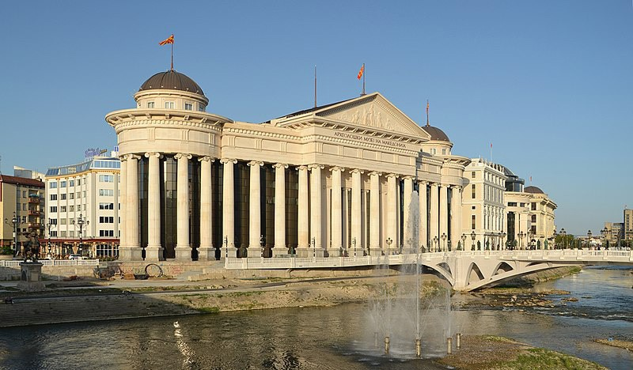

### Archeological Museum of Macedonia

EVENTS AND CULTURAL LIFE

**Face without of masks *(April)*** *- Theater festival.*

**VinoSkop Spring *(May)* -** *It’s wine fest in Skopje close to Vero Center.*

**Skopje Street Art Festival (Baskerfest) *(June)*** *- Festival about all forms of street art : Graffiti, Dance, Music, Culture, Lifestyle... They have good program with contest of dance, live music, performance graffiti...*

**Paratissima *(June)*** *- Good festival about contemporary art and dance. It’s in MKC with some exhibitions and performances.*

**Pivofest *(September)*** *- Beer festival at the Fortress of Skopje.*

**VinoSkop *(September)*** *- It’s the main wine fest in Macedonia. Every year, around 25 wineries come in Skopje and during 5 days make party !*

**Skopje Jazz Festival *(October)*** *- Classic jazz festival.*

#### MKC (or Mladinski kulturni centar)

- *it’s Youth Cultural Center. There are concerts, exhibitions, performances.*

**Kino Millenium** - *in GTC. it’s a cheap cinema, around 120 or 180 MKD for one ticket.*

**Kinoteka** *- On Partisanka Boulevard.*

**Cineplexx** - *Cinema at Skopje City Mall.*

**Kino Kultura** - *it’s a cultural center with exhibitions. It’s real interesting place. Check on internet, because they move their place in this moment.*

**Theatre of Skopje** - *It’s close to “Rekord Bus Station”*

**Opera and Ballet of Skopje** *- Nice place and good price. Between 300 MKD and 800 MKD for one ticket. They have a good program and the concert room has a really good acoustic.*

*Also you can find really good discounts on this website:* https://grouper.mk/ *or* https://kupinapopust.mk/

## European YOUTH CARD

The European Youth Card is a card for young peple offering a large number of discounts as culture, travel, accomodation, shopping and services in most of european countries.

This card costs between 5 and 19 € but you will get it for free... :-)

The card is usually used and valid for one year.

You can find more informations on : http[s://w](http://www.eyca.org/)ww.e[yca.org/](http://www.eyca.org/)

# Discover Macedonia

**Veles** (1 afternoon)

Close to Skopje, around 30/45 min by Bus, it’s a little city. You can find some restaurants or bars, walk across the city and discover the Clock Tower and also the Bridge of Veles.

**Tetovo** (1 day)

From Skopje, you need 1h to go to this city. The city is not so cute, but they have a beautiful «Paint Mosque» in the city center. You can also discover the «Monastry of Derviches» at the end of the city.

**Gostivar** (1 day)

You need 1h30 to go to Gostivar, it’s a nice place to discover old traditional city of Macedonia. Also, you can take a Taxi for 3€ and go to Vrutok. It’s the source of Vardar and there is a restaurant close to the source. This place is really cute.

**Mavrovo** (1 day)

At 2h by bus, great place for hiking in forest or around the lake. Also, in winter, you can practise skiing.

**Bitola** (1 weekend)

Nice city in south of Macedonia.

**Vevchani** ( for the Carnival in January / 2 days )

The best carnival ever in Balkans and really famous around the world. Insane and

strange. Vevchani is really cute, it’s a traditional city of Macedonia.

**Ohrid Lake** (1 week-end)

Located in south of Macedonia, 3h by bus from Skopje, it’s a perfect place for hot summer. You can take a rest around the lake and discover one of the most beautiful city of Macedonia.

[**http://www.exploringmacedonia.com/**](http://www.exploringmacedonia.com/)

## MAP OF SKOPJE

MAP OF MACEDONIA

Advices to survive in Macedonia !

### TAKE IT EASY!

Take your time! You don´t need to hurry :-) (They won´t hurry either)

### CURIOSITY IS ESSENTIAL!

Be curious and prepared for surprises!

### DON´T JUDGE!

Forget about stereotypes and stay open-minded!

### WATCH OUT ON THE STREET!

Be careful while walking on the streets ! Drivers are (sometimes) crazy here

### LEARN MACEDONIAN!

Then you can talk to local people and explore more

### ILLEGAL TAXI ARE FREQUENT!

Don´t get into any kind of taxi and be careful about the prices they charge you

with.

### TRY LOCAL FOOD AND DRINKS!

Enjoy macedonian food which is delicious even more with a glass of wine,

beer or rakija while listening to local music: it will be unforgettable!

### HOT SUMMER AND COLD WINTERS!

Be prepared for amazingly hot summer but also severe winters. You can go swimming in summer and go skiing in winter. Amazing, right?

### BUY VEGETABLES AND FRUITS ON THE LOCAL MARKET!

You can buy fresh vegetables and fruits and local specialities in local stores

and bazaars. It’s incredibly tasty and cheap.

### THE MOST IMPORTANT: ENJOY!

Enjoy every moment you have in Macedonia. Some things will surprise you, some will make you wonder, some will make you pleased or sad. Appreciate and take all of those moments.